


  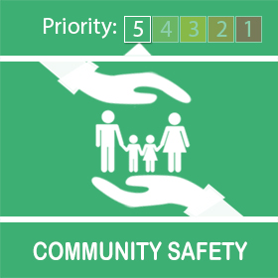
  Coronavirus Update from Your Local Police


While we’re all staying home more than normal, we’re asking you to continue being vigilant and look out for your neighbours, family and friends during this uncertain time.
We encourage you to remind elderly and vulnerable neighbours to never answer the door to anyone they are not expecting and always ask for ID if there’s any doubt.
Please stay alert and at home as much as possible and follow the government guidance.

How we’ve been working with places of worship
Did you know that as part of our work to keep you safe during this pandemic we’ve been working with faith leaders?
Early on in this global health emergency, places of worship led the way in keeping people safe by closing their doors for public prayer.
They quickly adapted and switched to only vital community work like operating foodbanks, preparing and delivering free meals for people in need, broadcasting online services and offering funeral arrangements.
Each week our chaplain and a senior officer met online with representatives of the region’s main faiths. They told us what churches, mosques, mandirs, gurdwaras and other centres were doing in every neighbourhood. They explained how a small number of volunteers would need to work safely to make this happen and the rituals they needed to perform behind closed doors to keep their faiths alive. We were able to share this information with people living nearby to help them understand why they would sometimes see a few people coming and going.
Together with the West Midlands Combined Authority and the Police and Crime Commissioner, we were able to share important safety information through the group as well as learn about how the lockdown was affecting people in your neighbourhood.
We’d like to send a big thank you to everyone who was involved in that stage and the work we’ve got planned for the future.
Places of worship remain closed until 4 July at the earliest in line with government guidelines.

Know, Look, Act
It’s vital that we all remain vigilant, especially during lockdown when the usual lines of contact for children are reduced.
We’re sharing the poster below with you to help you understand what to look out for if you think a child is being abused or exploited.
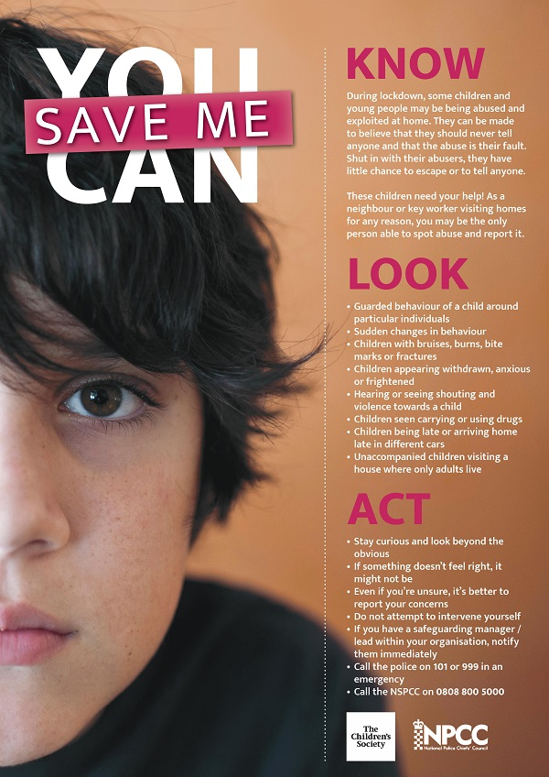

Diary of a key worker
This week, Asim Janjua from our Corporate Communications team, is featured in our ‘diary of a key worker’ series, which brings you the personal stories of our officers and staff who are working across the force to keep you safe during this pandemic.
Asim celebrated Eid very differently this year because of coronavirus.
You can read Asim’s story and see the other diaries of key workers here.


Contact us
It’s really important we keep our phone lines free so we can prioritise 999 emergencies and help those most in need.
For all non-emergencies we ask you to visit our website first. Here you can:
- Search for advice on a range of issues
- Report crime such as theft, criminal damage or burglary
- Speak to us on Live Chat between 8am to midnight
Stay safe and take care.
Unfortunately, we won’t be able to answer any replies to this message. However, you can speak to us via live chat on our website www.west-midlands.police.uk This is available every day between 8am and midnight, and the wait time is often less than calling us.

