
This week we entered a new phase of the restrictions put in place to tackle coronavirus. People are allowed to move around more freely than they have been, but still with some significant limits.
Our approach to the lockdown will not change – we will continue to use common sense and discretion. We’ll be engaging with people and explaining the rules, and encouraging them to follow them.
Enforcement will continue to be a last resort.
We’re incredibly grateful for the support the people of the West Midlands have given us over the recent weeks. We’ll continue to work together to keep the region safe and healthy through this difficult time.
Find out more on our website.

Staying safe online
We’ve seen a steady rise in coronavirus related online fraud. Keep yourself safe online by following the guidance below:
- Secure accounts - use strong passwords and never share your password
- Account privacy settings - restrict who can see your profile, posts and photos
- Turn off GPS/location settings on your mobile
- Think about what you post publicly
- Ensure your computer and other devices have updated antivirus software
- Change your password on your home Wi-Fi router
- Look at putting a pin or password on your phone to prevent others from using it

To get the latest information about how to protect yourself from these scams, visit the Action Fraud website.

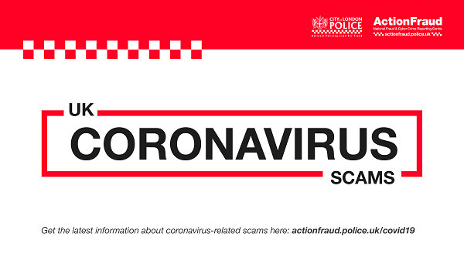

What's been happening in your area?
Birmingham police partnerships youth officers have been visiting families and pupils from local schools across the city. Offering help and support to those who need it most.
Good to see that they are safe and staying in doors!!
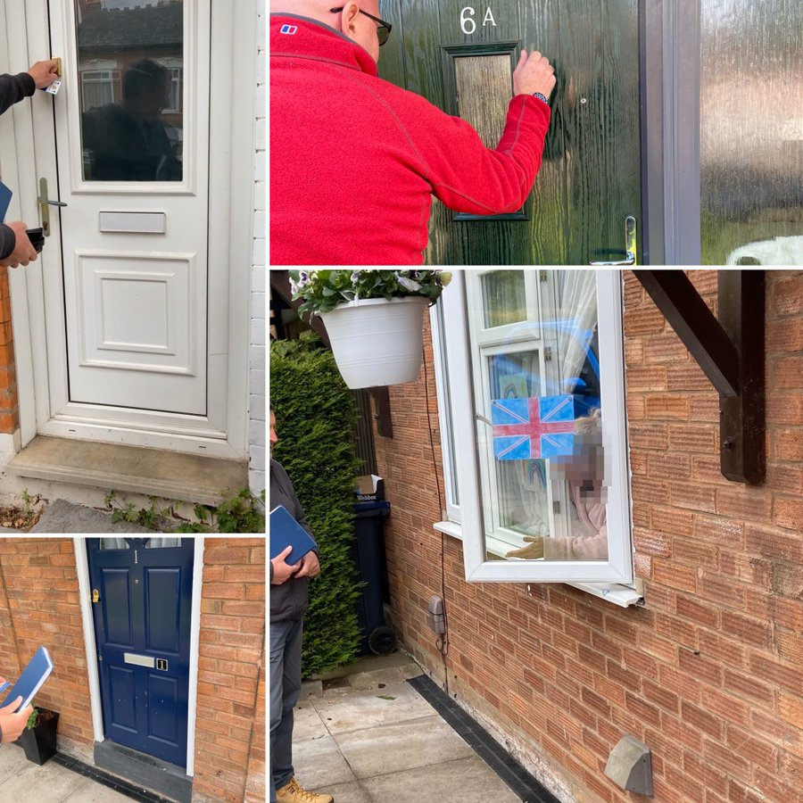

Diary of a key worker
We’ve created a new ‘diary of a key worker’ series to bring you the personal stories of our officers and staff who are working across the force to keep you safe during this pandemic.
Chloe Herrmann is a Resourcing Manager, usually based at our head office in central Birmingham and would normally travel throughout the West Midlands to attended recruitment events and meet candidates.
Because of CoVID-19 she’s working from home and has been doing so longer than most people because she’s pregnant and classed as vulnerable.
Read more here.
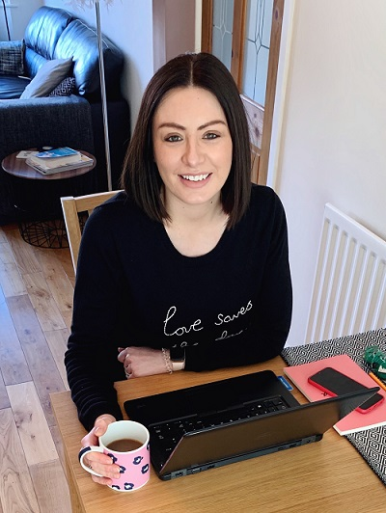

Contact us
It’s really important we keep our phone lines free so we can prioritise 999 emergencies and help those most in need.
For all non-emergencies we ask you to visit our website first. Here you can:
- Search for advice on a range of issues
- Report crime such as theft, criminal damage or burglary
- Speak to us on Live Chat between 8am to midnight
Stay safe and take care.
Unfortunately, we won’t be able to answer any replies to this message. However, you can speak to us via live chat on our website www.west-midlands.police.uk This is available every day between 8am and midnight, and the wait time is often less than calling us.

