West Midlands COVID-19 Update
Last updated: Friday,12th June 2020 18:00

Purpose of this briefing
This is a regularly updated document which aims to give to regional stakeholders:
- An overview of the spread of COVID-19 in the urban West Midlands (Birmingham, Coventry, Dudley, Sandwell, Solihull, Walsall and Wolverhampton)
- A single view of the actions of the West Midlands Combined Authority (WMCA), Transport for West Midlands (TfWM) and the Mayor in response to COVID-19
- A guide to where to find detailed regional information to support the existing national Government guidance

Latest Headlines
There have been 8885 confirmed cases of COVID-19 in the West Midlands (as of 12th June)
- Thousands of high street shops, department stores and shopping centres to reopen safely on Monday in England [more]
- Face coverings to become mandatory on public transport in England from Monday [more]
- Mayor and Severn Trent CEO host recovery roundtable [Thursday June 11th]
- Two big employers join WMCA scheme to boost apprenticeships at small companies. [Tuesday June 9th]
- Big Summer of Cycling and Walking campaign launches with plans to improve safety on roads and high streets. [Monday June 8th]

Key messages to the public

Stay alert – Control the virus – Save lives
We can all help control the virus if we all stay alert. This means you must:
- stay at home as much as possible
- work from home if you can
- limit contact with other people
- keep your distance if you go out (2 metres apart where possible)
- wash your hands regularly
- do not leave home if you or anyone in your household has symptoms

Message from Andy Street, Mayor of the West Midlands
“As we move towards a further relaxation of lockdown restrictions on Monday, it is encouraging to see our number of new infections continue to slowly decline. We are now regularly in the ‘teens, and lowering numbers of confirmed cases coupled with Test, Trace and Isolate process should drive Coronavirus out of the West Midlands altogether.
“On Test, Trace and Isolate, I am confident that this process is up and running, and indeed the latest figures I have seen show 95% of contacts identified in the region are being traced. There is perhaps a concern, outlined by the Health Secretary, that not everyone who tests positive is volunteering contacts, and I would urge everyone in the West Midlands to do their bit by working with the process if they do test positive.
“As a former retailer I also cannot not comment on the re-opening of non-essential retail stores on Monday. This is a very visual sign of the re-opening of the West Midlands economy, and I know stores will have done all they can to make themselves safe in preparation for customers. I’m personally looking forward to seeing shops open next week so that retailers can resume trading and get our economy moving again.”

Further Information
- Details of WMCA COVID-19 support and guidance are available here
- Latest WMCA Communications updates are available here
- You can find the most up to date medical advice [here]
- Coronavirus FAQs – what you can and can’t do [here]
- Bereavement support available [here]

Latest COVID-19 Public Health England and NHS update
There have been 8885 confirmed cases of COVID-19 in the West Midlands (as of 12th June).

Confirmed Cases (the numbers are cumulative)
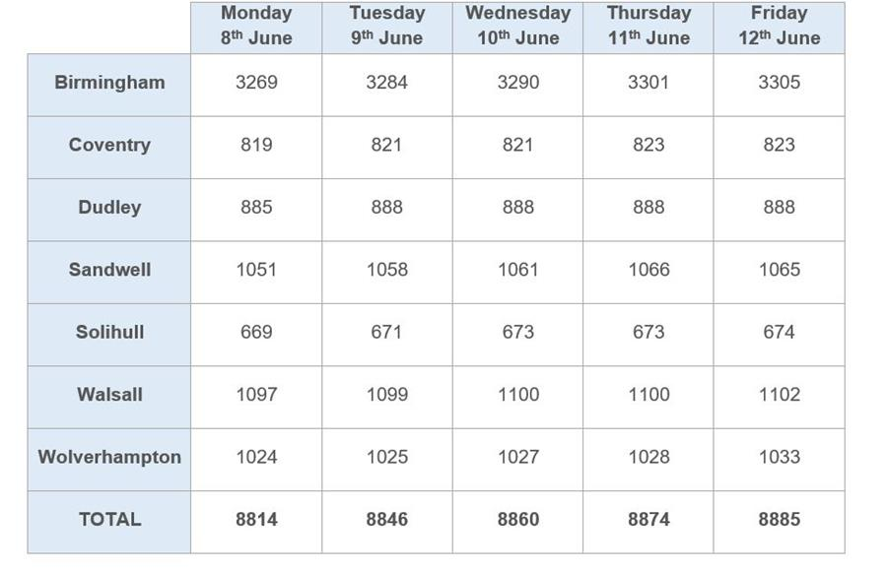

Further information
- Latest PHE/NHS information on COVID-19 cases in the West Midlands

West Midlands Combined Authority (WMCA) Response to COVID-19
The WMCA has been focused on the following six areas of activity in response to COVID-19, working closely with our seven constituent councils, and focusing on the areas where the Combined Authority can add to what is being done by Government and other public bodies:
- Strategic Co-ordination across the Public Sector: Working together across the public sector to ensure that the response to COVID-19 is joined up and effective as possible.
- Protecting the Regional Economy: Working with businesses and representative organisations to make sure that support is provided to businesses and workers to ensure the West Midlands economy can recover as swiftly as possible following the COVID-19 outbreak.
- Running the Transport Network: There is a reduced but sufficient service on train, Metro and bus networks to allow workers to get to their work in a safe manner. We are also providing free transport to NHS workers.
- Supporting All Our Communities: Ensuring all communities of the West Midlands are looked after during the COVID-19 outbreak, including all faith and ethnic minority groups and other vulnerable groups such as the homeless, those with mental health issues or disabilities and older people
- Communicating with the Public: Giving clear guidance to people in the West Midlands about what they are expected to do during the COVID-19 outbreak
- Adapting the WMCA’s Own Operations: Ensuring our staff are safe and healthy, while continuing the activities of the WMCA

Strategic Co-ordination across the Public Sector
Context: The response to COVID-19 requires joined-up working between different public sector organisations to tackle the outbreak and the impact on public services and the regional economy. The WMCA is well-positioned to work closely with public sector bodies given its existing collaborative working relationships, particularly with councils and with those agencies involved in transport, housing, skills, employment, policing and health.
The purpose of this activity is:
- Work closely with other public sector organisations
- Support regional resilience planning and resourcing
The structures leading this work in the West Midlands are:
- Regional Strategic Co-ordinating Group: (Senior leaders from West Midlands Police, Councils, NHS, PHE, WMCA) reporting to COBR in London
- Recovery Co-ordination Group to provide strategic leadership and coordination to the region’s recovery planning and delivery.
- Regular Mayor and Council Leaders Conference Calls (Mayor, Council Leaders, Respective Chief Executives, briefed by other agency leaders e.g. Chief Constable of West Midlands Police)
- Calls between the Mayor and leaders from the NHS, Public Health England, Police and other public bodies

Protecting the Regional Economy
Context: The public health measures which have been implemented to slow the spread of COVID-19 are having a huge impact on the West Midlands economy. Government has put in place unprecedented support measures to help businesses and workers through this time. The WMCA is working with representative organisations to make sure that this support is getting through to businesses and workers and is working on plans to accelerate the economic recovery after the COVID-19 outbreak.

The purpose of this activity is:
- Monitor the latest economic situation for businesses in the West Midlands on a weekly basis through WM-Redi
- Ensure Government support is reaching West Midlands businesses and workers
- Lobbying Government to secure further support for West Midlands businesses and workers
- Prepare for the economic recovery following the COVID-19 outbreak
- Connect West Midlands businesses with the frontline public sector organisations e.g. the NHS, who may need support
The structures leading this work in the West Midlands are:
- Regular Economic Impact Group meetings (WMCA, Councils, TUC, LEPs, Chambers of Commerce, West Midlands Growth Company, Bank of England, BEIS)
Latest updates:
- Mayor and Severn Trent CEO host recovery roundtable [Thursday June 11th]
- The WM-Redi Monitor highlighted a recent report comparing ethnic unemployment and finding West Midlands unemployment rates stark, where 11% of ethnic minority groups are unemployed compared to 5% of white groups. Disparities in health outcomes, educational outcomes, crime, age, income and hostile immigration, all contribute to racial inequalities. CV19 is likely to worsen these issues. Although there aren’t recent data on claimants by ethnicity, preCV19 Black or Black British groups faced higher unemployment levels. Mapping where the increases in claimants are, these are largely in areas with high black populations and greater employment in sectors which are closed.
Retail footfall fell to 20% of its 2019 levels and remains below 40%, with West Midlands and North East seeing the highest falls between 74% and 76%, however the lowest fall is still significant at 68%.
Consumer spending data shows small towns geared around tourism are hardest hit. There is a significant localisation effect leading to inner city areas doing better than suburbs. Consumer spend in Coventry has seen a 47% drop, Birmingham saw a 42% drop and Wolverhampton and Walsall a 46% drop.
There is a rising concern about redundancies with a rise from 2,400 in April to 5,500 in May. Significant regional announcements include Rolls Royce, Aston Martin, Triumph, Churchill China and Forterra, with Intu Merry Hill putting administrators on standby.
- This week’s Economic Impact Group meeting heard that Business Grants, this week, across the seven metropolitan areas, paid a further £14.3m to 1,287 businesses. This brings total payments to £422.8m to 35,713 businesses. Business organisations expressed frustration at the lack of preparedness and planning in order to avoid a no-deal Brexit. WMCA will call on business representation organisations to collate a response to government on the regional impact of Brexit.

Running the Transport Network
Context: Bus, train and tram services are reduced. Further changes to timetables are being made over the coming weeks to bring more services back in to use to respond to the easing of the lockdown, however capacity will still be limited. Transport for West Midlands’ aim is to provide a reliable and safe service for those who need to use it for work and essential journeys.
The purpose of TfWM’s activity is:
- Run a limited service to allow people to access work and residents to be able to access essential shopping and healthcare
- Protect the health and safety of all those working on the transport network
- Ensure that operators are able to reinstate full transport services when the lockdown is finished
- Provide free travel for NHS staff and manage a shuttle service from stations and park and rides to hospitals
The structures leading this work in the West Midlands are:
- Transport for West Midlands
- Bus Alliance (bus operators across the West Midlands)
- West Midlands Rail Executive (councils and rail operators in the West Midlands)
Latest updates
Passenger Travel Advice
- Only use public transport if you have no other travel options. This keeps services safe and available for those who need them most. Walk, cycle or drive if you can but you should continue to stay at home as much as possible.
- When making essential journeys on public transport stay apart and, from Monday June 15th, you must wear a face covering. Find out how to make and use a face covering here
- Social distancing is important to keep you and transport staff safe.
- Big Summer of Cycling and Walking campaign launches with plans to improve safety on roads and high streets. [Monday June 8th]
- Transport’s role within the regional recovery will be critical to help securing a fairer, greener and healthier West Midlands post pandemic. This means the safe and well-coordinated remobilising of the transport system in the short term and accelerating our infrastructure delivery programmes to support recovery in the longer term.

Supporting All Our Communities
Context: During this challenging time for the region, all communities need to come together to support people, particularly those who are vulnerable. The WMCA and councils are working together to ensure that community efforts can contribute to the overall response to the COVID-19 outbreak effectively.
The purpose of this activity is:
- Work with faith and community organisations to co-ordinate support for those who need it
- Support vulnerable communities in the West Midlands like those with mental health issues, disabilities or the homeless
The structures leading this work in the West Midlands are:
- Faith leaders who have previously been engaged by the WMCA, for example at the Mayor and Faith Conference
- WMCA and Mayor’s Office working closely with local authorities
Latest updates:
- First meeting held of Panel to help guide West Midlands Covid-19 recovery [Friday June 12th]
- Two big employers join WMCA scheme to boost apprenticeships at small companies. [Tuesday June 9th]
- ​There is a fortnightly webinar for faith communities which the Mayor hosts. The next session on 17 June will be about Community Cohesion including Hate Crime Sign up to attend here. Faith groups and charities can see available sources of funding here
- The Government has shared some further guidance on reopening places of worship this morning, which you can see here
- Community Support Hub website remains live, allowing people to see what local groups are near them if they want to volunteer. There are over 400 community groups on the website, including details of virtual faith services in each local authority area.
- The Community Champions blog celebrates the volunteering efforts of our community heroes during the Covid-19 crisis, sharing stories, ideas and inspiration from across the West Midlands. If you have a story that you'd like to be featured, please get in touch via email: volunteers@wmca.org.uk

Communicating with the Public
Context: During the COVID-19 outbreak, it is critical that the public understand the medical guidance and act accordingly to tackle the virus. Due to restrictions on contact, public services will also have to change, and these changes need communicating to the public. Furthermore, this will be a worrying time for residents, and there is a need to reassure and comfort people, and to celebrate positive stories of people supporting one another through the crisis.
The purpose of this activity is:
- Ensure people in the West Midlands understand the Government’s guidance
- Provide clear regional guidance on changes to public services, such as new transport timetables or skills provision.
- Explain what is being done in the West Midlands and reassure the public that there is a committed regional response to the crisis
- Make the case for further Government support
The structures leading this work in the West Midlands are:
- Regular Regional Press Briefing Sessions: These briefing sessions for the press are hosted by representatives from a range of public sector organisations in the region, including the Mayor, Public Health England, the NHS, West Midlands Police, the West Midlands Police and Crime Commissioner, Birmingham City Council, and the Local Resilience Forum.
- West Midlands Regional Communications Directors’ Calls: These calls allow Communications Directors from councils, the WMCA and other public bodies to co-ordinate communications activities across the West Midlands.
- Amplifying the Government’s official guidance on COVID-19 to people in the West Midlands through the WMCA’s communications channels.
- Providing clear regional guidance on changes to public services, such as new transport timetables or skills provision.
- Explaining what is being done in the West Midlands and making the case for further Government support through the Mayor’s media appearances.
Latest updates:
- This afternoon’s press briefing session featured questions on the economy, policing football matches, recruitment of BAME police officers, statues in towns and cities, rough sleepers and face coverings on public transport. You can watch the press briefing here.

Adapting WMCA’s Own Operations
Context: The WMCA as an organisation has responsibilities for supporting economic growth in the West Midlands, including transport, housing, skills, and making sure everyone in the West Midlands benefits from that economic growth through work on areas like mental health and homelessness. During the COVID-19 outbreak, the WMCA will adapt to support the immediate needs of the West Midlands, working closely with public sector partners, and will also ensure that essential WMCA activities continue.
The purpose of this activity is:
- Keep our staff and those of our suppliers safe and healthy during the COVID-19 outbreak
- Reprioritise effort towards meeting the immediate needs for tackling the COVID-19 outbreak
- Ensure essential WMCA operations continue
The structures leading this work in the West Midlands are:
- WMCA Senior Leadership Team, led by Deborah Cadman, Chief Executive, WMCA
- TfWM Leadership Team, led by Laura Shoaf, Managing Director, TfWM



