West Midlands COVID-19 Update
Last updated: Friday, 29th May 2020 17:30

Purpose of this briefing
This is a regularly updated document which aims to give to regional stakeholders:
- An overview of the spread of COVID-19 in the urban West Midlands (Birmingham, Coventry, Dudley, Sandwell, Solihull, Walsall and Wolverhampton)
- A single view of the actions of the West Midlands Combined Authority (WMCA), Transport for West Midlands (TfWM) and the Mayor in response to COVID-19
- A guide to where to find detailed regional information to support the existing national Government guidance
Latest Headlines

- There have been 9350 confirmed cases of COVID-19 in the West Midlands (as of 28th May).
- Government launched the NHS Test and Trace service yesterday. This will form a central part of their coronavirus recovery strategy. Anyone with symptoms will be tested and their close contacts will be traced. New guidance means those who have been in close contact with someone who tests positive must isolate for 14 days, even if they have no symptoms, to avoid unknowingly spreading the virus. [how it works]
- Government urged to use West Midlands as test bed for early reopening of tourism, hospitality and cultural sector. [Wednesday 27th May]
- The West Midlands Combined Authority’s Homelessness Taskforce has urged the Government to act now to prevent a post-COVID-19 surge in homelessness across the region. [Saturday 23rd May]
- Experts to lead Advanced Manufacture in Construction group to help ramp up West Midlands housing supply. [Wednesday 27th May]

Key messages to the public

Stay alert – Control the virus – Save lives
We can all help control the virus if we all stay alert. This means you must:
- stay at home as much as possible
- work from home if you can
- limit contact with other people
- keep your distance if you go out (2 metres apart where possible)
- wash your hands regularly
- do not leave home if you or anyone in your household has symptoms

Message from Andy Street, Mayor of the West Midlands
“We are on a downward trend of new infections, and a huge thank you must go to the people of the region who have shown a remarkable sense of responsibility to help bring this infection figure down.
“Because of this we are now in a position where we can safely accommodate a further easing of lockdown measures, and I welcome the Prime Minister’s announcement yesterday that people will be able to meet in groups of six from Monday – providing they stick to the social distancing measures.
“I also welcome the return of car showrooms from Monday, and more traditional retail shops from June 15. Both are important to our regional economy and will be clear visible signs for people that we are moving back towards some form of normality.
“These new steps can only be taken in the West Midlands because of a low rate of infection, combined with a comprehensive track and trace system. That system went live across the region yesterday, and we will use it to drive Coronavirus out of the region, one case by one case.
“Meanwhile work continues at pace on the region’s economic recovery plan, and we have been lobbying extensively this week over support for our region’s automotive sector. We are also pushing for our hospitality, tourism, and cultural sectors to be used as a pilot for the UK, meaning we would be able to open this sector up first and lead the way for the rest of the country.”

Further Information
- Details of WMCA COVID-19 support and guidance are available here
- Latest WMCA Communications updates are available here
- You can find the most up to date medical advice here
- Coronavirus FAQs – what you can and can’t do [here]

Bereavement Support
We understand that losing a loved one can feel overwhelming, especially if the death was sudden, untimely and unexpected.
There are a number of organisations who can support you and your family during this distressing time.
These include:
- Find bereavement services from your council
- For a step-by-step guide after a bereavement click here
- Cruse Bereavement Care has online resources on how bereavement and grief may be affected by this pandemic, click here to find out more. Alternatively, call their free helpline: 0808 808 1677
- For facts about the coronavirus and supporting children click here
- The Compassionate Friends offer support to families after the death of a child of any age and from any cause. Visit their website or alternatively, call: 0345 123 2304

Latest COVID-19 Public Health England and NHS update
There have been 9350 confirmed cases of COVID-19 in the West Midlands (as of 28th May).

Further information
- Latest PHE/NHS information on COVID-19 cases in the West Midlands

West Midlands Combined Authority (WMCA) Response to COVID-19
The WMCA has been focused on the following six areas of activity in response to COVID-19, working closely with our seven constituent councils, and focusing on the areas where the Combined Authority can add to what is being done by Government and other public bodies:
- Strategic Co-ordination across the Public Sector: Working together across the public sector to ensure that the response to COVID-19 is joined up and effective as possible.
- Protecting the Regional Economy: Working with businesses and representative organisations to make sure that support is provided to businesses and workers to ensure the West Midlands economy can recover as swiftly as possible following the COVID-19 outbreak.
- Running the Transport Network: There is a reduced but sufficient service on train, Metro and bus networks to allow workers to get to their work in a safe manner. We are also providing free transport to NHS workers.
- Supporting All Our Communities: Ensuring all communities of the West Midlands are looked after during the COVID-19 outbreak, including all faith and ethnic minority groups and other vulnerable groups such as the homeless, those with mental health issues or disabilities and older people
- Communicating with the Public: Giving clear guidance to people in the West Midlands about what they are expected to do during the COVID-19 outbreak
- Adapting the WMCA’s Own Operations: Ensuring our staff are safe and healthy, while continuing the activities of the WMCA

Strategic Co-ordination across the Public Sector
Context: The response to COVID-19 requires joined-up working between different public sector organisations to tackle the outbreak and the impact on public services and the regional economy. The WMCA is well-positioned to work closely with public sector bodies given its existing collaborative working relationships, particularly with councils and with those agencies involved in transport, housing, skills, employment, policing and health.
The purpose of this activity is:
- Work closely with other public sector organisations
- Support regional resilience planning and resourcing

The structures leading this work in the West Midlands are:
- Regional Strategic Co-ordinating Group: (Senior leaders from West Midlands Police, Councils, NHS, PHE, WMCA) reporting to COBR in London
- Recovery Co-ordination Group to provide strategic leadership and coordination to the region’s recovery planning and delivery.
- Regular Mayor and Council Leaders Conference Calls (Mayor, Council Leaders, Respective Chief Executives, briefed by other agency leaders e.g. Chief Constable of West Midlands Police)
- Calls between the Mayor and leaders from the NHS, Public Health England, Police and other public bodies

Protecting the Regional Economy
Context: The public health measures which have been implemented to slow the spread of COVID-19 are having a huge impact on the West Midlands economy. Government has put in place unprecedented support measures to help businesses and workers through this time. The WMCA is working with representative organisations to make sure that this support is getting through to businesses and workers and is working on plans to accelerate the economic recovery after the COVID-19 outbreak.
The purpose of this activity is:
- Monitor the latest economic situation for businesses in the West Midlands on a weekly basis through WM-Redi
- Ensure Government support is reaching West Midlands businesses and workers
- Lobbying Government to secure further support for West Midlands businesses and workers
- Prepare for the economic recovery following the COVID-19 outbreak
- Connect West Midlands businesses with the frontline public sector organisations e.g. the NHS, who may need support
The structures leading this work in the West Midlands are:
- Regular Economic Impact Group meetings (WMCA, Councils, TUC, LEPs, Chambers of Commerce, West Midlands Growth Company, Bank of England, BEIS)

Latest updates:
- Government urged to use West Midlands as test bed for early reopening of tourism, hospitality and cultural sector. [Wednesday 27th May]
- Experts to lead Advanced Manufacture in Construction group to help ramp up West Midlands housing supply. [Wednesday 27th May
- The WM-Redi Monitor highlighted further plans for unlocking the economy have been revealed with non-essential retailers able to open from 15th June (contingent on the Covid-19 situation).
- This week’s Economic Impact Group meeting heard that business grants, in the last week, across the seven Mets, paid a further £26.7m to 2,327 businesses. This brings the totals to £390.6m paid to 32,881 businesses since early April. Concern was expressed at the introduction of quarantine rules for arrivals at UK airports - this will be discussed in detail next week and a representative of Warwick University outlined how social distancing at 1metre would allow an intake of 16,000 students but at 2 metres this reduces to just 4,000.

Running the Transport Network
Context: Bus, train and tram services are reduced. Further changes to timetables are being made over the coming weeks to bring more services back in to use to respond to the easing of the lockdown, however capacity will still be limited. Transport for West Midlands’ aim is to provide a reliable and safe service for those who need to use it for work and essential journeys.
The purpose of TfWM’s activity is:
- Run a limited service to allow people to access work and residents to be able to access essential shopping and healthcare
- Protect the health and safety of all those working on the transport network
- Ensure that operators are able to reinstate full transport services when the lockdown is finished
- Provide free travel for NHS staff and manage a shuttle service from stations and park and rides to hospitals

The structures leading this work in the West Midlands are:
- Transport for West Midlands
- Bus Alliance (bus operators across the West Midlands)
- West Midlands Rail Executive (councils and rail operators in the West Midlands)
Latest updates
- Safer travel guidance for passengers [here]
- Peak time restrictions on free travel passes to be reinstated as more people return to work and school [Thursday 28th May]
- Clampdown launched following rise in spitting incidents on the buses. [Friday 29th May]​​
- Growth on the transport network has remained at low levels, reduced by around 85% compared to pre-covid levels, although this does vary between modes. Overall numbers using rail are still less than 90% of the pre-COVID levels.
- The advice given to passengers is to continue to work from home if this is possible, reduce the number of journeys you make and consider active travel choices such as walking and cycling. If public transport is required then passengers are requested to plan ahead, consider face coverings and hand sanitiser, maintain social distance and utilise contact payment where possible.
- Transport’s role within the regional recovery will be critical to help securing a fairer, greener and healthier West Midlands; post pandemic. This means the safe and well-coordinated remobilising of the transport system in the short term and accelerating our infrastructure delivery programmes to support recovery in the longer term.

Supporting All Our Communities
Context: During this challenging time for the region, all communities need to come together to support people, particularly those who are vulnerable. The WMCA and councils are working together to ensure that community efforts can contribute to the overall response to the COVID-19 outbreak effectively.

The purpose of this activity is:
- Work with faith and community organisations to co-ordinate support for those who need it
- Support vulnerable communities in the West Midlands like those with mental health issues, disabilities or the homeless
The structures leading this work in the West Midlands are:
- Faith leaders who have previously been engaged by the WMCA, for example at the Mayor and Faith Conference
- WMCA and Mayor’s Office working closely with local authorities
Latest updates:
- Generous West Midlands residents and businesses donate more than £150,000 to help homeless [Thursday 28th May]
- A Birmingham healthcare assistant is using the skills she is learning in a course funded by the West Midlands Combined Authority (WMCA) to help patients coming into the region’s busiest A&E department. [Wednesday 27th May]
- The West Midlands Combined Authority’s Homelessness Taskforce has urged the Government to act now to prevent a post-COVID-19 surge in homelessness across the region.[Saturday 23rd May]
- There is a fortnightly webinar for faith communities which the Mayor hosts, the next one is on 3 June and will be about Places of Worship. Sign up to attend here. Last week’s session was on Finance and Funding. Faith groups and charities can see available sources of funding here
- Community Support Hub website remains live, allowing people to see what local groups are near them if they want to volunteer. There are over 400 community groups on the website, including details of virtual faith services in each local authority area.
- The Community Champions blog celebrates the volunteering efforts of our community heroes during the Covid-19 crisis, sharing stories, ideas and inspiration from across the West Midlands. If you have a story that you'd like to be featured, please get in touch via email: volunteers@wmca.org.uk

Communicating with the Public
Context: During the COVID-19 outbreak, it is critical that the public understand the medical guidance and act accordingly to tackle the virus. Due to restrictions on contact, public services will also have to change, and these changes need communicating to the public. Furthermore, this will be a worrying time for residents, and there is a need to reassure and comfort people, and to celebrate positive stories of people supporting one another through the crisis.
The purpose of this activity is:
- Ensure people in the West Midlands understand the Government’s guidance
- Provide clear regional guidance on changes to public services, such as new transport timetables or skills provision.
- Explain what is being done in the West Midlands and reassure the public that there is a committed regional response to the crisis
- Make the case for further Government support
The structures leading this work in the West Midlands are:
- Regular Regional Press Briefing Sessions: These briefing sessions for the press are hosted by representatives from a range of public sector organisations in the region, including the Mayor, Public Health England, the NHS, West Midlands Police, the West Midlands Police and Crime Commissioner, Birmingham City Council, and the Local Resilience Forum. You can see the latest press briefing here.
- West Midlands Regional Communications Directors’ Calls: These calls allow Communications Directors from councils, the WMCA and other public bodies to co-ordinate communications activities across the West Midlands.
- Amplifying the Government’s official guidance on COVID-19 to people in the West Midlands through the WMCA’s communications channels.
- Providing clear regional guidance on changes to public services, such as new transport timetables or skills provision.
- Explaining what is being done in the West Midlands and making the case for further Government support through the Mayor’s media appearances.

Latest updates:
- This afternoon’s press briefing session featured questions on NHS Track and Trace; challenges for the police around relaxing of lockdown measures and premier league football matches; the impact of Covid-19 on BAME communities and changes to the government furlough scheme. You can watch the press briefing here
- Peak time restrictions on free travel passes to be reinstated as more people return to work and school [Thursday 28th May]

Adapting WMCA’s Own Operations
Context: The WMCA as an organisation has responsibilities for supporting economic growth in the West Midlands, including transport, housing, skills, and making sure everyone in the West Midlands benefits from that economic growth through work on areas like mental health and homelessness. During the COVID-19 outbreak, the WMCA will adapt to support the immediate needs of the West Midlands, working closely with public sector partners, and will also ensure that essential WMCA activities continue.
The purpose of this activity is:
- Keep our staff and those of our suppliers safe and healthy during the COVID-19 outbreak
- Reprioritise effort towards meeting the immediate needs for tackling the COVID-19 outbreak
- Ensure essential WMCA operations continue
The structures leading this work in the West Midlands are:
- WMCA Senior Leadership Team, led by Deborah Cadman, Chief Executive, WMCA
- TfWM Leadership Team, led by Laura Shoaf, Managing Director, TfWM




  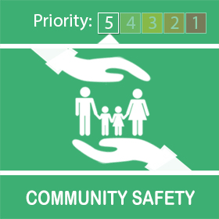
  Coronavirus Update from Your Local Police


While we’re all staying home more than normal, we’re asking you to continue being vigilant and look out for your neighbours, family and friends during this uncertain time.
We encourage you to remind elderly and vulnerable neighbours to never answer the door to anyone they are not expecting and always ask for ID if there’s any doubt.
Please stay alert and at home as much as possible and follow the government guidance.

How we’ve been working with places of worship
Did you know that as part of our work to keep you safe during this pandemic we’ve been working with faith leaders?
Early on in this global health emergency, places of worship led the way in keeping people safe by closing their doors for public prayer.
They quickly adapted and switched to only vital community work like operating foodbanks, preparing and delivering free meals for people in need, broadcasting online services and offering funeral arrangements.
Each week our chaplain and a senior officer met online with representatives of the region’s main faiths. They told us what churches, mosques, mandirs, gurdwaras and other centres were doing in every neighbourhood. They explained how a small number of volunteers would need to work safely to make this happen and the rituals they needed to perform behind closed doors to keep their faiths alive. We were able to share this information with people living nearby to help them understand why they would sometimes see a few people coming and going.
Together with the West Midlands Combined Authority and the Police and Crime Commissioner, we were able to share important safety information through the group as well as learn about how the lockdown was affecting people in your neighbourhood.
We’d like to send a big thank you to everyone who was involved in that stage and the work we’ve got planned for the future.
Places of worship remain closed until 4 July at the earliest in line with government guidelines.

Know, Look, Act
It’s vital that we all remain vigilant, especially during lockdown when the usual lines of contact for children are reduced.
We’re sharing the poster below with you to help you understand what to look out for if you think a child is being abused or exploited.
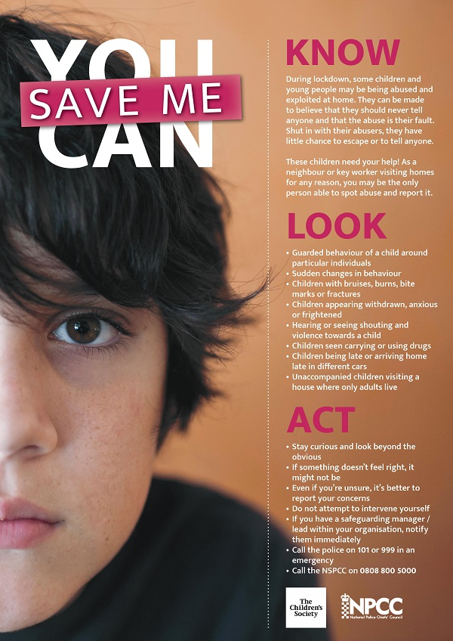

Diary of a key worker
This week, Asim Janjua from our Corporate Communications team, is featured in our ‘diary of a key worker’ series, which brings you the personal stories of our officers and staff who are working across the force to keep you safe during this pandemic.
Asim celebrated Eid very differently this year because of coronavirus.
You can read Asim’s story and see the other diaries of key workers here.


Contact us
It’s really important we keep our phone lines free so we can prioritise 999 emergencies and help those most in need.
For all non-emergencies we ask you to visit our website first. Here you can:
- Search for advice on a range of issues
- Report crime such as theft, criminal damage or burglary
- Speak to us on Live Chat between 8am to midnight
Stay safe and take care.
Unfortunately, we won’t be able to answer any replies to this message. However, you can speak to us via live chat on our website www.west-midlands.police.uk This is available every day between 8am and midnight, and the wait time is often less than calling us.

